Live Polls in the Conference App
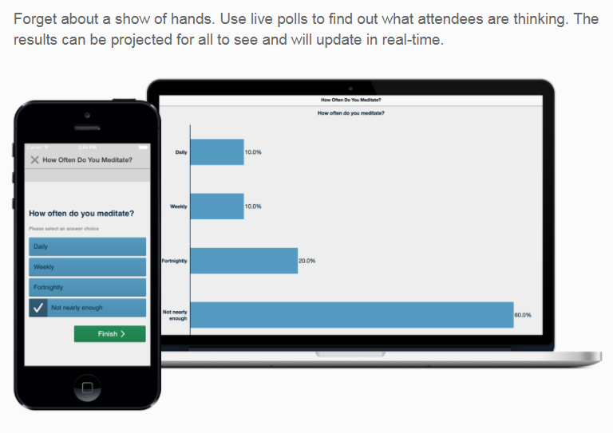
Attendee Votes
Results on screen
How It Works:
- Submit your poll question(s) following the Character Limits and Poll Question Types below
  - Scroll to bottom to email your polling questions
- Receive a custom PPT slide for the poll
- Import the slide into your presentation
- On the Live Poll slide, click “Enable content” or “Trust this app” (& Update”) if you see a warning.
- View the slide in slideshow mode to see live results
- Attendees vote in app (Your session > Live Poll > Tap answer > Tap SUBMIT)
- Bar chart updates live with every vote

How It Works With Repeated Sessions:
- One slide for first session
- Different slide for second session
- See end of this document for additional options

Character Limits:
  - Questions: 300 characters or less
  - Answer choices: 140 characters or less

Polling Question Types:
- Multiple Choice. Limit your answer choices to less than 5.
  - Single Answer
  - Multiple Answer (all that apply)
- Additional Options:
  - Include N/A or
  - Include Other and let attendees type in answers
Additional Options for Viewing Results:
- A single session: The PowerPoint Slide will display the results on a bar graph as attendees vote.
- Repeated sessions (the same question asked during different sessions):
  - You will need one PowerPoint slide per poll per session.
  - You will need to make sure you have the correct slide “unhidden” in your presentation for the session or just duplicate your Presentation and use a separate one for each session.
- Cumulative results from repeated sessions: Attendees will use an icon on the app home page to go to the Live Poll. You will use just one PPT slide (per question) in your presentation.

Email Your Polling Questions (for PPT slide creation) to Brenda.Ainsburg@Siemens.com

Ensure your slides display the results:
Click the PREVIEW button on the bottom right | 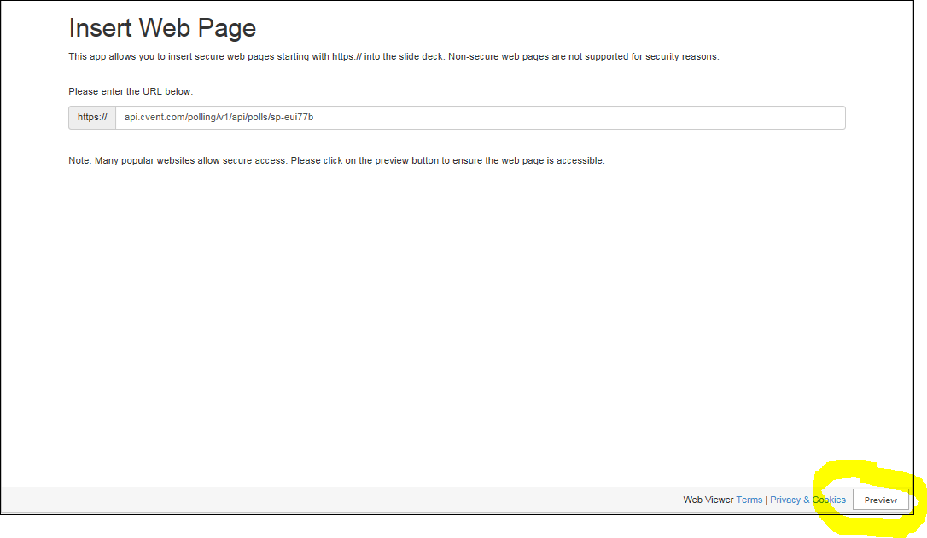
The Live Poll will display 0% if attendees have not yet voted.  Percent increases as attendees vote. | 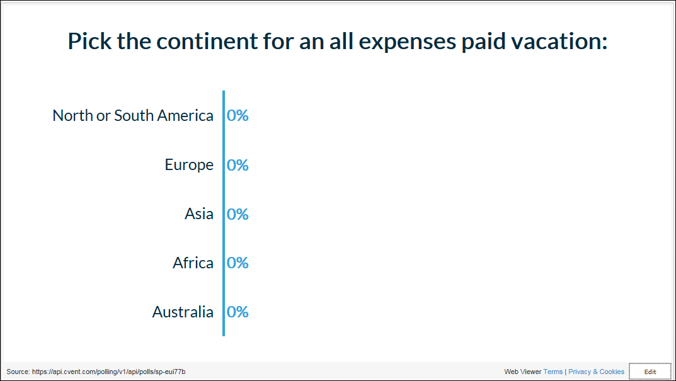
If you see a yellow triangle in the top-left corner, you need to follow these steps
- Click on yellow triangle | 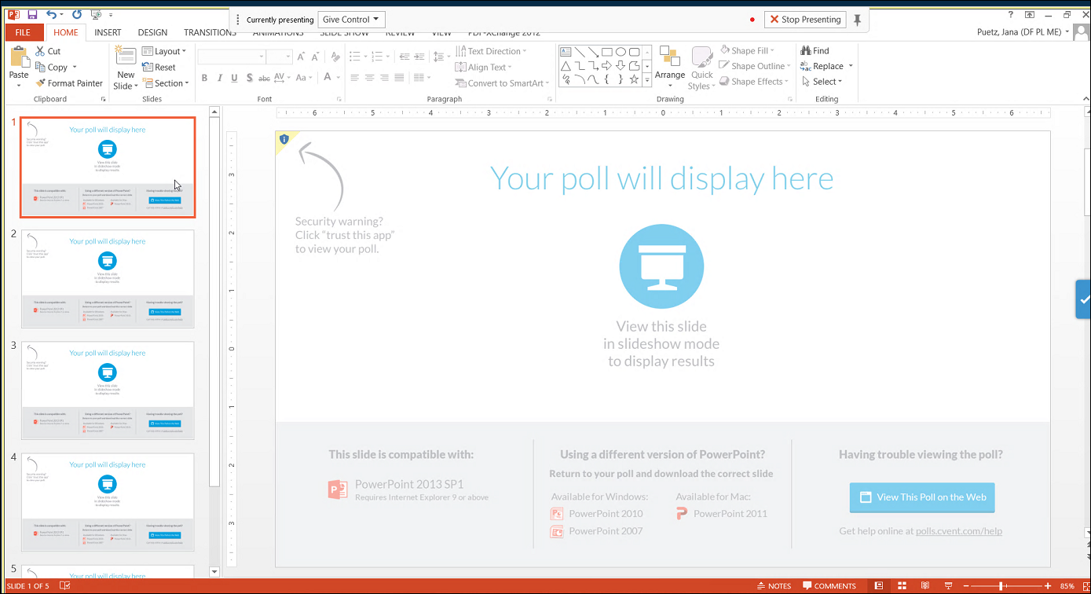
- Click “Trust this app” | 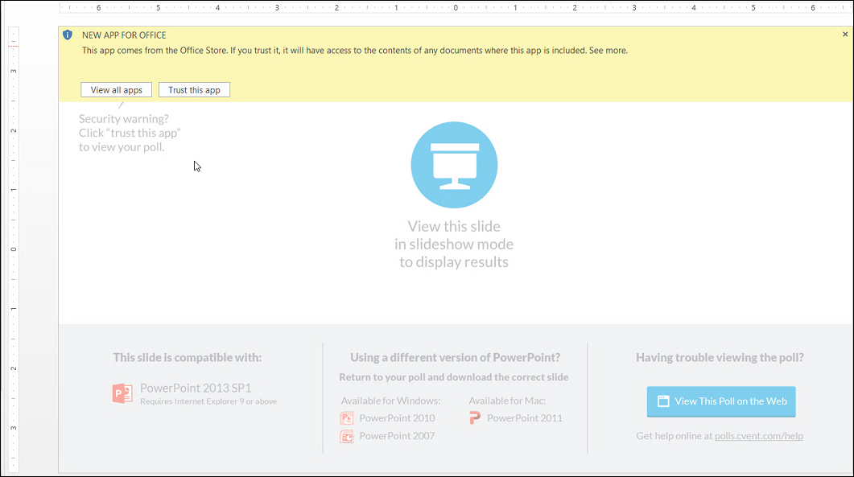
- Click on Yellow triangle again and click “Update” | 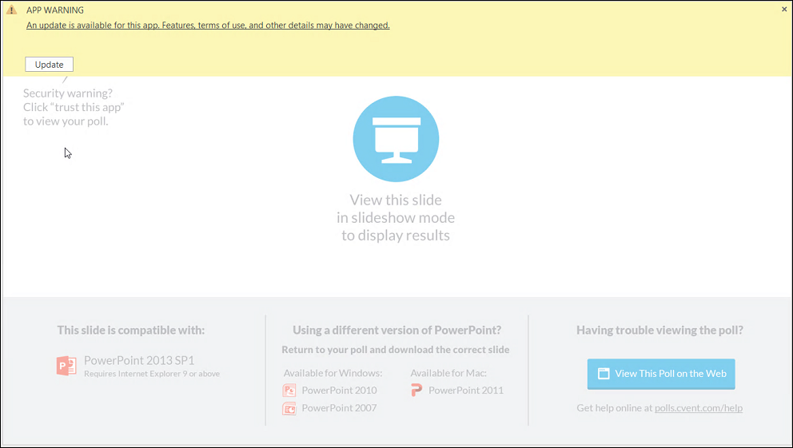
- Click on Preview on the bottom right
Your live poll now displays (0% if no one has yet voted)

