**Faculty Zoom Tips for NC School of Banking**

**Before the Week of the School**

* **Register for Orientation**

You have received a calendar hold for orientation with the registration link. The link is also below.

* Junior Faculty pleaseregister [**here.**](https://ncbankers-org.zoom.us/meeting/register/tZEvduCqrDwtHd1kceWb3R4Iaqm6KUnGZJ9C)
* Senior Faculty please register [**here.**](https://ncbankers-org.zoom.us/meeting/register/tZYrcOyvpj4qGdFkGxAp3WPGEljZNBZNI12H)
* **Create a Zoom Account**

Instructions provided below titled “Creating a Zoom Account.”

**The Week of the School**

* **Joining**

Please join *at least* 15 minutes before each simulation and review. If you don’t join at least 15 minutes before, we will call you.You will be able to join up to one hour in advance.

* **Zoom Reminders**

Please go through the checklist on the last page titled “Zoom Reminders,” before joining (steps 1-5).

* **Joining Simulations**

There is one link to join all simulations throughout the week. This link is provided on the website and will be on your calendar. No registration is required for this.

* **School Website & Accessing Links**

If you are looking for any links throughout the week, you will find them under the tab titled “Junior Curriculum” or “Senior Curriculum.” The class tabs will be made available on July 20. Also starting on Monday, July 20, the school website will be password protected. The password is **NCSB2020.**

**Creating a Zoom Account**

On your web browser, go to <https://zoom.us/freesignup/>.

* It will ask for your work email, but you can use your personal email if you prefer.
* Enter your date of birth and then click “continue.” You must enter the correct year you were born. If you don’t, it will not allow you to create an account.
* It will say “Please confirm your email to get started.” Click “confirm.”
* You will then need to check your email for a confirmation link from [**no-reply@zoom.us**](mailto:no-reply@zoom.us)**.**
* Click on “Activate Account” inside the email.
* It will ask you if you are registering with a school – **CLICK “NO.”**
* You can click “Skip” when it asks if you want to invite colleagues.
* Your Zoom account has now been created.

Now, please provide the email you signed up with on Zoom. [Click HERE](https://www.surveymonkey.com/r/HDFWSV2) to submit the email address that you used to register for Zoom with.

**\*It is very important you provide us with the correct email address that you registered your Zoom account with. We will be using this email to put you in simulation groups throughout the week.** If you have any issues creating a Zoom account, please contact [mckenna@ncbankers.org](mailto:mckenna@ncbankers.org) prior to the start of school.

* **Browser vs Zoom App:** You can use your web browser to access Zoom throughout the week. You can also use the PC app for Zoom. When you join your first Zoom meeting, it will ask you if you want to download the app version. If you want to install the PC app version before the first meeting, click [HERE.](https://cvent.me/E5zPRV)
* **Zoom Tips and Best Practices:** During orientation, all students will go over Zoom tips. In their teams, students will be able to share their screen and participate as if they were together in-person.

**Zoom Tools**

* **Chat Feature:** An NCBA staff member will manage the chat feature. An NCBA staff member can let you know if there are questions to address.
* **Breakouts:** All breakouts will be uploaded in Zoom. Breakouts are assigned by teams. You will need to let the Tech Help know when you are ready for the students to join their breakouts. They will then launch the breakouts.

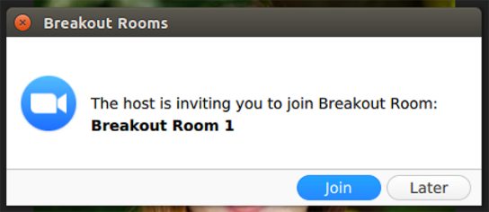

* **Joining Breakouts:** If you want to join any of the breakout rooms, you will let the Tech Help know which room you want to join. You can ask him verbally. If you don’t get moved, you can also utilize the chat feature - his name will be listed as listed as “AV Help.” You will then receive a notification to join.
* **Leaving Breakouts:** You will click “Leave Breakout Room,” when you are ready to leave. Be sure to click “Leave Breakout Room,” and not leave meeting. If you leave the breakout meeting, you will be sent back to the main room.
* **Sharing your screen****:** Click the “Share Screen” button located in your meeting controls. This will be at the bottom of your screen.
  + Select the screen you want to share. If you are only sharing your PowerPoint, you can select just that application.
  + You can also choose an individual application that is already open on your computer, the desktop, a whiteboard, or an iPhone/iPad.
  + Optional Feature:
    - Check “Share Computer Sound.” If you check this option, any sound played by your computer will be shared in the meeting.
    - Check “Optimize” for full screen video clip: Check this if you will be sharing a video clip in full screen mode. Do not check this if you aren’t sharing a video clip, as it may cause the shared screen to be blurry. Click “Share.” Additional instructions on sharing your screen are located [HERE](https://support.zoom.us/hc/en-us/articles/201362153-Sharing-your-screen)

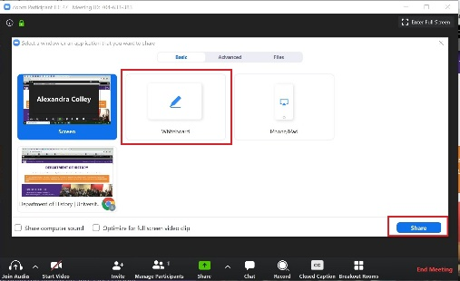

* **Whiteboard:** If you want to us the whiteboard feature, click “Share Screen.” Select the **Whiteboard** and click on “Share.” When you click on the **Whiteboard**, the annotation tools will become available. The annotation tools will show up at the top of your screen.

**Zoom Reminders**

1. **Device**

* Please join from your laptop with access to a webcam and audio.
* If you are sharing your screen for results or a PowerPoint, please have it pulled up and ready to be shared. A reminder on how to share your screen is listed below under Zoom tools.

1. **Video**

* The room should be well-lit; avoid any backlighting behind your head. Too much light, such as a big window behind your head, can cause a glare.
* If connecting from a laptop, plug into a power source. Battery use can affect video quality
* Dress is business casual.
* While sharing a PowerPoint, the attendees will see your PowerPoint big and your video will be minimized in the corner. Just a reminder that your view is different than the attendees.

1. **Audio**

* Be sure your location is quiet and background noise is at a minimum.

1. **Tests Prior**

* Test your video and audio connection at <https://zoom.us/test>.
* Make sure that you have a good Wi-Fi signal. We recommend a minimum speed of 20mbps. Test your internet speed here: [http://speedtest.net](http://speedtest.net/).

1. **General**

* **Silence devices.** Turn off notifications on other devices that may go off during your classes (email notifications, phone ringing, etc.)
* You will get a notification saying you are now the “Co-host**.”** This will allow you to share your screen.
* During your session, you will have a NCBA staff member and Tech Help from the Friday Center. Their names will be listed as Tech Help and NCBA Help. Please locate these two resources by clicking “Participants” in your Zoom controls at the bottom of your screen.