**TOPIC: Access Portal Pages and Unique Reports**

Continuing the “*Tip of the Week*” conversations about Access Portals that were share by [Béline Falzon](https://community.cvent.com/network/members/profile?UserKey=46793fab-028a-4cd3-8a80-7cb31902a384) ([Setting up your Access Portal](https://protect-us.mimecast.com/s/IcMDCqxLqKfOoD91CNbDgx?domain=community.cvent.com)) and [Loretta Peterson](https://community.cvent.com/network/members/profile?UserKey=a3361f37-1f73-460d-bcca-13ecaf004251) ([New Reports Tips & Tricks](https://protect-us.mimecast.com/s/FyG3CrkVrLHAGpxrtN2V7V?domain=community.cvent.com)), I thought I would share with you what I have recently added to enhance my company’s Access Portal, aka our “Event Resource Center.” I added a page for “Previous Webinar Topics” for our sales teams in other regions who wish to duplicate content without having to reinvent the wheel. I built a report, copied the URL, embedded it in the word **HERE** and provided the following instructions.

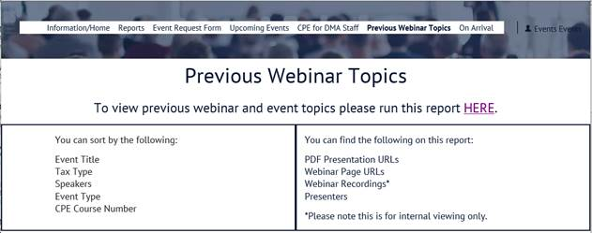

* In the Admin section under Account/Custom Fields/Custom Event Fields, I created a few custom event fields to allow the user to sort by unique values such as topic, speaker or event type as well as have the ability to view links to the PDF presentations and webinar recordings.
* I customized a report in the Cross Events Report section which includes a few standard fields such as the summary page links. This link takes them to the event web page (or archive page after the event).
* The user can sort by whatever field they wish.
* In addition to the noted fields, I also include the numbers of those who were sent an invitation, registered for the event, attended and were a no-show so the sales team can determine if the webinar/event was successful enough to duplicate.
* This is all saved in one report on one page so that they do not have to sort through all the previous event reports.

**Updating your Archive Page**

As noted above, I updated the events’ archived pages to mirror the summary page so that the event information can be referenced long after the event is over. This is very easy by using the option “Duplicate to another page.”

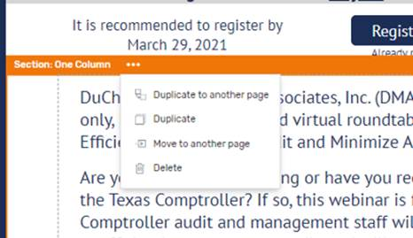

I added a column with text saying: “This event is in the past. Interested in attending our upcoming events? Reach out to us to get more information or go to [DMAinc.com](https://urldefense.com/v3/__https:/dmainc.com/events__;!!IktuQFw!hebNCxtPOv0GKqwzssAGqaTvW1Oo5L1ERsTC2eMZ_Zp_9qLZbGzYDlrIfdZhsw$).” to ensure there is not any confusion about the event. The register button automatically becomes disabled.

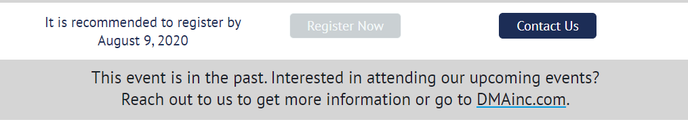Having this detailed archive page is also very helpful for our attendees who need to have the event content information for their CPE credits should they have neglected to grab it during the registration process.

**Access Portal Home Page**

Another enhancement we made to the Access Portal is a “Home Page” to provide an explanation of what each page contains. We took the web URL from each individual Access Portal page and hyperlinked each page for easy access; ([Lori Wildman’s](https://community.cvent.com/network/members/profile?UserKey=5fb57048-d812-4f57-b6a5-2cae00bec490) fantastic idea). We hid some pages from the navigation bar to reduce clutter (such as the SOP pages), but the links take you to the pages.

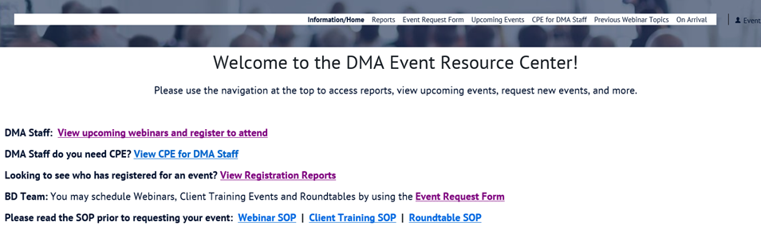

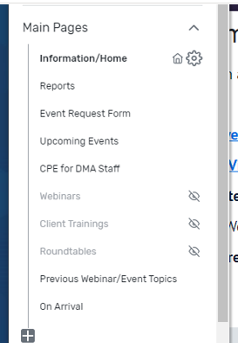

What unique pages or reports have you made for your Access Portal to enhance your event management processes? Please share below!