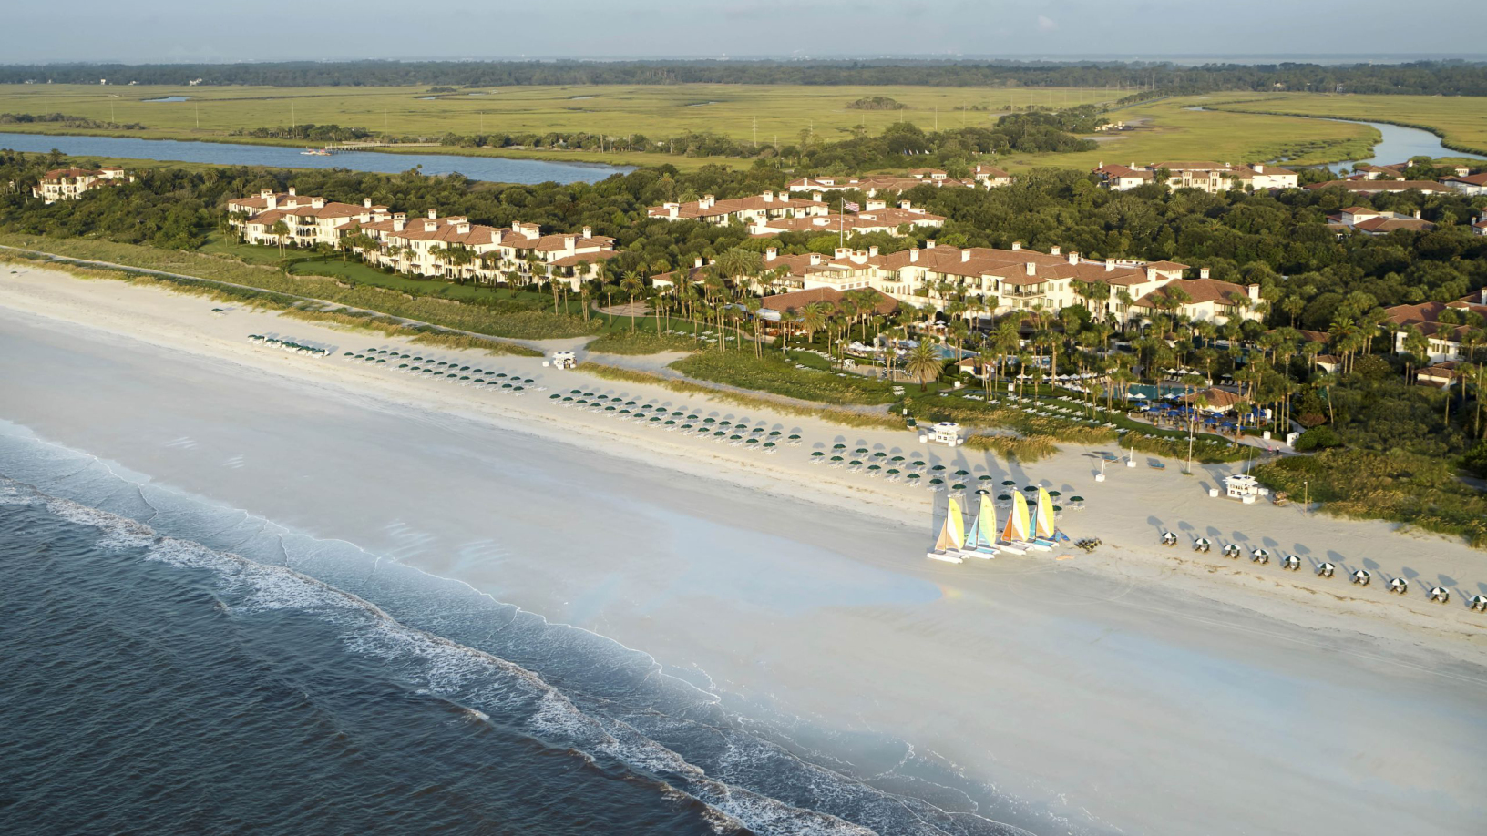 Sea Island, Georgia