Hi Cvent Community! My name is Michele Gebrayel from Marietta, GA! This week I will be providing tips on how to track registrations that come from other places beside an email invitation as well as how to create consistency throughout your web pages and emails by using Reference IDs, Data Tags, Widgets and the Header and Footer.
How do you cross-promote your event? Our sales team wanted to see who was driving attendance to our events, as we compensate our inside sales team if their targeted invitees register. You can create a unique link for each source you use as a registration driver (ie: individual sales team members, LinkedIn, your website, paid ads, etc.).
Go to Promotions & Communications>Weblinks>Create Link. You can then create the name of the person or source, with a unique link indicator. You can make it obvious such as “LinkedIn” or something that only the internal team would know such as particular numbers or initials of the person (“mS” for Mary Smith).
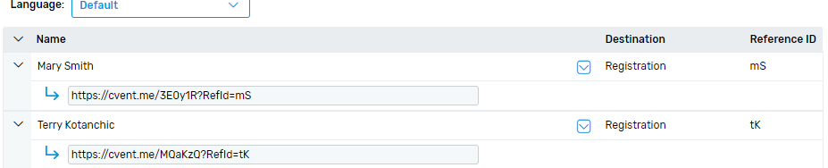
When you run a report, you will see where the registration comes from if you choose to include the option “Reference ID”:
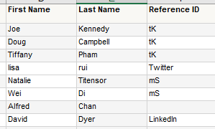
Where are your registrations coming from? Do you know?
My second tip is to utilize the event Data Tags, Widgets and the Header and Footer. Automation is key with events. Making a template to ensure your company’s branding is consistent, setting your colors and creating a standard page layout is a huge time saver.
You can create Custom Event Fields are required when setting up the event. I have created Custom Data Tags for the Custom Event Fields. Using Data Tags not only is this a timesaver, but it also eliminates accidental errors such as transposing characters or not updating imperative information when something changes such as the date or time of your event. By using the Widgets and Data Tags, everything will pull from the Event Information page. Variable information, such as our webinar password or number of CPE credits that are issued, will also update automatically.
In our “thank you for attending” email, we tell our attendees that they are welcome to reach out to their account manager and have that as a Custom Data Tag. When we upload our invitation list, we also include our account manger’s name, email and phone number. That information lives in the contacts profile. We also note that they can reach out to the presenter from the event. I created a list of presenters that I can select from a drop-down box when I create the event. I no longer have to manually type in the presenters and their contact information. All information will pre-populate when the email is sent out.

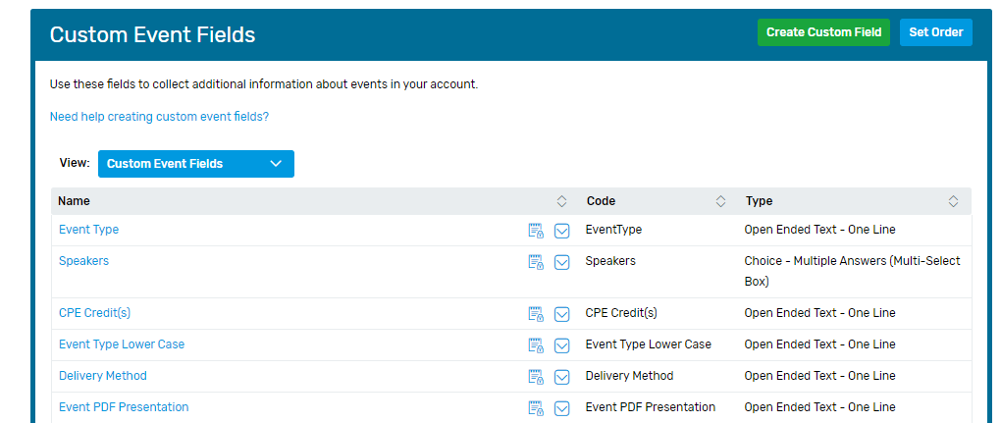
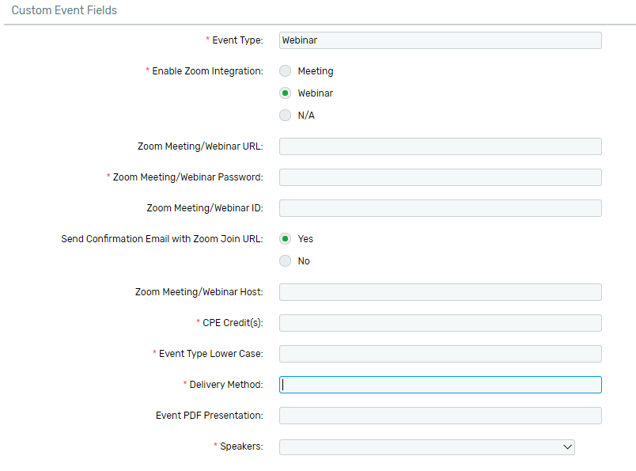
Need help creating custom event fields?
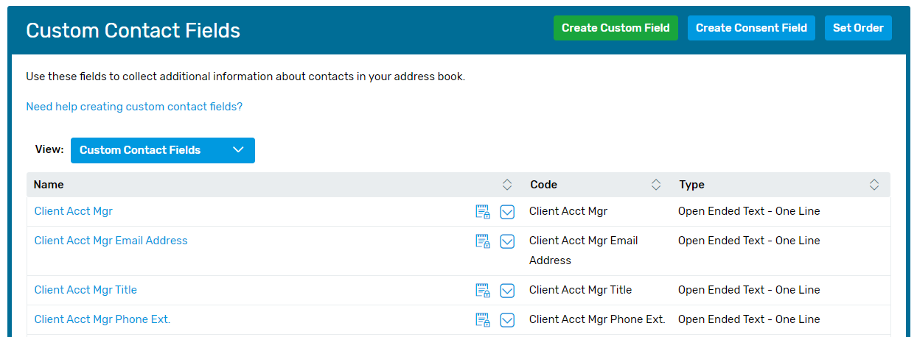
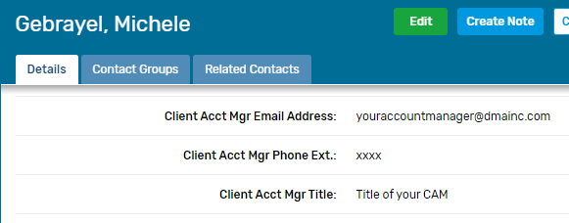
Need help creating custom contact fields?
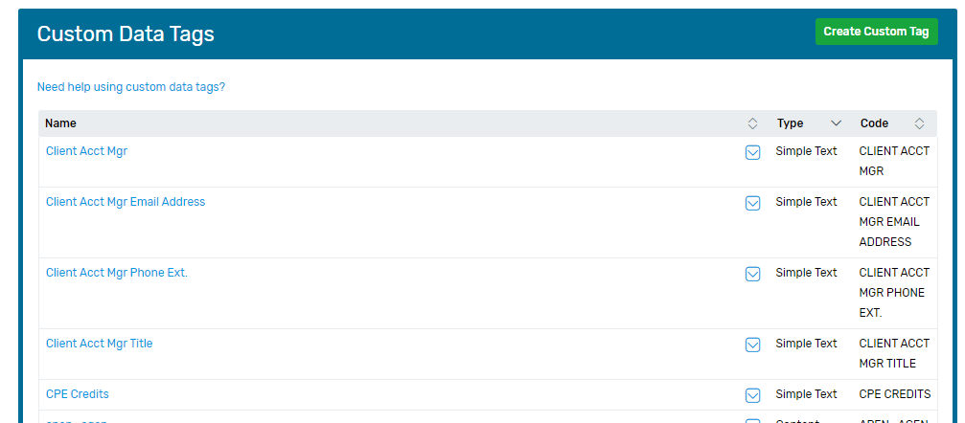
Need help using custom data tags?
Another timesaver is to put information that needs to be on each page or email in the Header and Footer rather than putting it on each individual page. This is very helpful, as we have this information on various pages in the website or the emails that we send out. This is especially useful if you have to make a one-off web page or new email. The Header and Footer will have the necessary information.
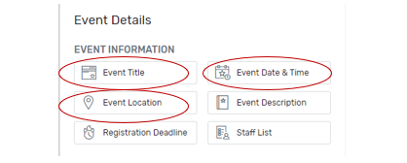
Is there anything you do that is a huge time saver or to prevents errors? Share below to let us know! #CventTip
In case you missed our session on Flex hacks at Cvent CONNECT Virtual, you can still watch the on-demand content here.

