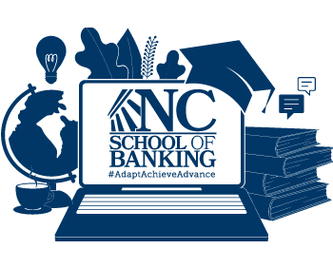

NCSB School Kickoff - Panelist Reminders

Title of Panel: Leadership During A Time of Change
Date: Monday, August 3rd, 2020

Reminders:
- Please join the meeting by 8:50 am.
- Please be in a well-lit and quiet area.
- When the meeting starts, all your videos will be set to OFF. We will turn your videos off after we do a quick test to make sure we see and hear you.

When your panel is about to start, you will receive the following notification from the host -
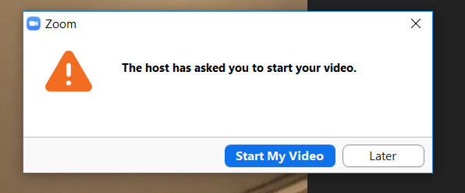

Please then click start my video.
As a reminder, the panelist view is different than the attendee view. Don’t worry if, as a panelist, you see black screens titled “NCBA” or another panelist. The attendees do not see this.

When your portion is over, you will see the following which states your video is no longer being seen.

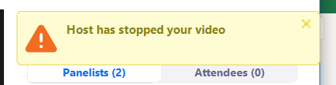

Important Numbers:
Blair Jernigan’s cell:
McKenna Gorham’s cell:

If you have technical issues with your video, please use the dial-in as a backup. This is in your calendar hold.
Thank you again!

