**Instructor Zoom Tips for NC School of Banking**

If you have added any polls, breakout rooms, or any additional Zoom functions to your presentation, please email McKenna Gorham at [mckenna@ncbankers.org](mailto:mckenna@ncbankers.org) and let her know of your additions. We want to ensure our tech manager and our staff know of any updates.

**Before Joining Your Live Rehearsal**

1. **Device**

* Please join from your laptop, with access to a webcam and audio.
* Please have your PowerPoint pulled up and ready to be shared. A reminder on how to share your screen is listed below under Zoom tools.

1. **Video**

* Please join the rehearsal in the room that you will be teaching from for your live session. The room should be well-lit; avoid any backlighting behind your head. Too much light, such as a big window behind your head, can cause a glare.
* If connecting from a laptop, plug into a power source. Battery use can affect video quality.
* Dress is business casual.
* While sharing a PowerPoint, the attendees will see your PowerPoint big and your video will be minimized in the corner. Just a reminder that your view is different than the attendees.

1. **Audio**

* Be sure your location is quiet and background noise is at a minimum.

1. **Tests Prior**

* Test your video and audio connection at <https://zoom.us/test>.
* Make sure that you have a good Wi-Fi signal. We recommend a minimum speed of 20mbps. Test your internet speed here: [http://speedtest.net](http://speedtest.net/).

1. **General**

* **Silence devices.** Turn off notifications on other devices that may go off during your classes (email notifications, phone ringing, etc.).
* You will get a notification saying you are now the “Co-host**.”** This will allow you to share your screen.
* During your session, you will have a NCBA staff member and Tech Help from the Friday Center. Their names will be listed as Tech Help and NCBA Help. Please locate these two resources by clicking “Participants” in your Zoom controls at the bottom of your screen.

**Day of your Live Session**

**Joining your session**

* Please arrive *at least* 15 minutes before your session. If you don’t join at least 15 minutes before, we will call you.You will be able to join up to one hour in advance.
* Please go through the checklist above that you reviewed before your rehearsal (steps 1 – 5) .

**Zoom Tools**

Some of you have marked you will be using various Zoom tools. Please find additional information below. Again, if you have added any tools to your presentation, please let [mckenna@ncbankers.org](mailto:mckenna@ncbankers.org) know.

* **Chat Feature:** An NCBA staff member in your session will manage your chat feature. During your live rehearsal, we will ask you for a few good stopping points for questions. During the live session, the NCBA Staff member can then let you know if there are questions to address.
* **Polling** (outside of knowledge checks): If you sent in poll questions, they have been entered in. During your live rehearsal, we will make sure we know when you want us to launch these. You will not have to launch them yourself.
* **Knowledge Checks** (only for Freshman and Sophomore instructors): We will launch your knowledge checks at the end of your live session. If you don’t have a live session, they will be launched at the end your office hours. You will need to tell the Tech Help when are done with your instruction/done with your office hours and ready for the Tech Help to launch the knowledge checks.
* **Breakouts:** If you marked you would be using breakout rooms we have uploaded the students into those rooms. During your live rehearsal, we will make sure we know when to launch those rooms. We will also need to know how long you want the students in each room. They will receive a notification to join the room. If you want to join any of the breakout rooms, you will let the Tech Help know and he/she can move you.

**Reminders**

* **Sharing your screen:** Click the “Share Screen” button located in your meeting controls.
  + The green arrow iconwill be at the bottom of your screen.
  + Select the screen you want to share. If you are only sharing your PowerPoint, you can select just that application.
  + You can also choose an individual application that is already open on your computer, the desktop, a whiteboard, or an iPhone/iPad.
  + **Optional Features:** 
    - **Whiteboard:** if you want to use the whiteboard feature, please click on “Share Screen.” Select “Whiteboard” and click “Share.” 
      * 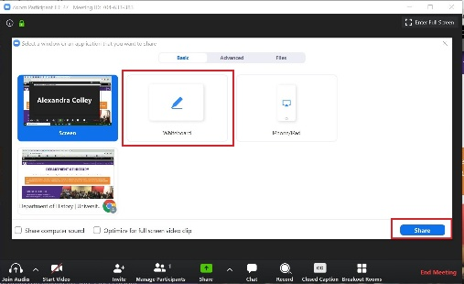When you click on “Whiteboard,” the annotation tools will become available and will be shown at the top of your screen.
    - **Sound**: Check “Share Computer Sound.” Any sound now played by your computer will be shared in the meeting.
    - **Video Clips**: Check “Optimize” for full-screen video clip. Do not check this otherwise, as it may cause the shared screen to be blurry. Click “Share.”
  + Additional instructions on sharing your screen are located [HERE](https://support.zoom.us/hc/en-us/articles/201362153-Sharing-your-screen).

**Please reach to** [**mckenna@ncbankers.org**](mailto:mckenna@ncbankers.org) **if you have any questions. We look forward to the live rehearsals!**