Tip of the Week: Why can't I delete an invitation list?  Did you know you actually can?!

Have you ever uploaded a list to an event and are then told you need to remove a group of contacts from receiving any future emails? When you try to do so, you will receive this message: “*Because invitations have already been sent for this list, you can only remove invitees individually. To prevent them from receiving future emails for this list, you can unsubscribe them*.” You can manually unsubscribe them or remove them out from the event, but for both situations, you have to do this for each contact one by one.

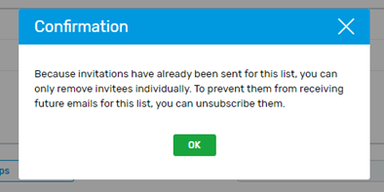

But did you know you can create a new invitation list, giving it a name such as “Delete”, re-upload the contacts you do not want in the event to the new list, select all, go to the List Member tab, then select “Remove” deleting all of the contacts in the second list and removing them from the event all at once?

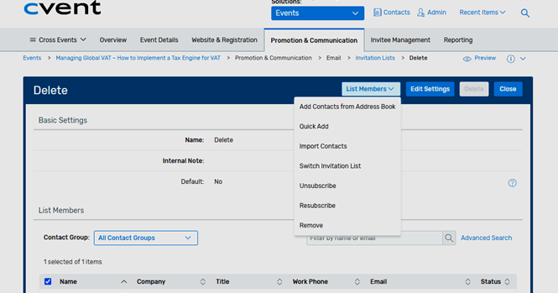

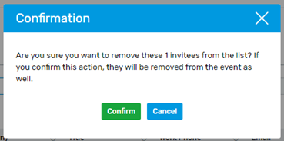

This situation just happened to me after an event was launched and an email was sent out, preventing me from deleting the list. There were 60 out of 17K contacts who were accidentally included in the list. I was first given about 30 contacts from one company that needed to be removed. I was able to sort them by the email nomenclature and unsubscribed them from the event, one by one. But then they gave me another random 30 contacts that could not be easily sorted for. I decided to create a new list and upload the random 30 so I did not have to hunt for all that needed to be pulled. It was then I discovered I could delete them all out of the second list and removing them event all at once.  I was thrilled to find this “hack”!

Here is the article in the Knowledge Base: [https://support.cvent.com/apex/CommunityArticle?id=000058915&Lang=en_US&searchTerm=invitation+list](https://protect-us.mimecast.com/s/mwU5C9rYokUmww3lhPadu9?domain=support.cvent.com)

Hopefully you will never need this, but if you do, it is a huge timesaver!

Do you have an awesome timesaver hack? Please share below!

#CventTip